Philippine Bidding Documents

SUPPLY, DELIVERY AND INSTALLATION OF VARIOUS NETWORK EQUIPMENT FOR NETWORK INFRASTRUCTURE - SDO DATA CENTER
(Bid Reference No. 2023-10-006)

Government of the Republic of the Philippines

Sixth Edition
July 2020

Preface

These Philippine Bidding Documents (PBDs) for the procurement of Goods through Competitive Bidding have been prepared by the Government of the Philippines for use by any branch, constitutional commission or office, agency, department, bureau, office, or instrumentality of the Government of the Philippines, National Government Agencies, including Government-Owned and/or Controlled Corporations, Government Financing Institutions, State Universities and Colleges, and Local Government Unit. The procedures and practices presented in this document have been developed through broad experience, and are for mandatory use in projects that are financed in whole or in part by the Government of the Philippines or any foreign government/foreign or international financing institution in accordance with the provisions of the 2016 revised Implementing Rules and Regulations of Republic Act No. 9184.

The Bidding Documents shall clearly and adequately define, among others: (i) the objectives, scope, and expected outputs and/or results of the proposed contract or Framework Agreement, as the case may be; (ii) the eligibility requirements of Bidders; (iii) the expected contract or Framework Agreement duration, the estimated quantity in the case of procurement of goods, delivery schedule and/or time frame; and (iv) the obligations, duties, and/or functions of the winning bidder.

Care should be taken to check the relevance of the provisions of the PBDs against the requirements of the specific Goods to be procured. If duplication of a subject is inevitable in other sections of the document prepared by the Procuring Entity, care must be exercised to avoid contradictions between clauses dealing with the same matter.

Moreover, each section is prepared with notes intended only as information for the Procuring Entity or the person drafting the Bidding Documents. They shall not be included in the final documents. The following general directions should be observed when using the documents:

- All the documents listed in the Table of Contents are normally required for the procurement of Goods. However, they should be adapted as necessary to the circumstances of the particular Procurement Project.

- Specific details, such as the “name of the Procuring Entity” and “address for bid submission,” should be furnished in the Instructions to Bidders, Bid Data Sheet, and Special Conditions of Contract. The final documents should contain neither blank spaces nor options.

- This Preface and the footnotes or notes in italics included in the Invitation to Bid, Bid Data Sheet, General Conditions of Contract, Special Conditions of Contract, Schedule of Requirements, and Specifications are not part of the text of the final document, although they contain instructions that the Procuring Entity should strictly follow.

- The cover should be modified as required to identify the Bidding Documents as to the Procurement Project, Project Identification Number, and Procuring Entity, in addition to the date of issue.

- Modifications for specific Procurement Project details should be provided in the Special Conditions of Contract as amendments to the Conditions of Contract. For easy completion, whenever reference has to be made to specific clauses in the Bid Data Sheet or Special Conditions of Contract, these terms shall be printed in bold typeface on Sections I (Instructions to Bidders) and III (General Conditions of Contract), respectively.

- For guidelines on the use of Bidding Forms and the procurement of Foreign-Assisted Projects, these will be covered by a separate issuance of the Government Procurement Policy Board.
Table of Contents

Glossary of Acronyms, Terms, and Abbreviations ………………………….3
Section I. Invitation to Bid……………………………………………………..6
Section II. Instructions to Bidders…………………………………………...11
1. Scope of Bid ………………………………………………………………………. 12
2. Funding Information………………………………………………………………. 12
3. Bidding Requirements ……………………………………………………………. 12
4. Corrupt, Fraudulent, Collusive, and Coercive Practices………………………….. 12
5. Eligible Bidders…………………………………………………………………… 12
6. Origin of Goods ………………………………………………………………….. 13
7. Subcontracts ……………………………………………………………………… 13
8. Pre-Bid Conference ………………………………………………………………. 13
9. Clarification and Amendment of Bidding Documents …………………………… 13
10. Documents comprising the Bid: Eligibility and Technical Components …………. 13
11. Documents comprising the Bid: Financial Component …………………………... 14
12. Bid Prices …………………………………………………………………………. 14
13. Bid and Payment Currencies ……………………………………………………… 15
14. Bid Security ………………………………………………………………………. 15
15. Sealing and Marking of Bids ……………………………………………………… 15
16. Deadline for Submission of Bids …………………………………………………. 15
17. Opening and Preliminary Examination of Bids ………………………………….. 15
18. Domestic Preference ……………………………………………………………… 16
19. Detailed Evaluation and Comparison of Bids ……………………………………. 16
20. Post-Qualification ………………………………………………………………… 16
21. Signing of the Contract …………………………………………………………… 16
Section III. Bid Data Sheet …………………………………………………..17
Section IV. General Conditions of Contract ……………………...………..19
1. Scope of Contract ………………………………………………………………… 20
2. Advance Payment and Terms of Payment ……………………………………….. 20
3. Performance Security ……………………………………………………………. 20
4. Inspection and Tests ……………………………………………………………… 20
5. Warranty …………………………………………………………………………. 20
6. Liability of the Supplier ………………………………………………………….. 21
Section V. Special Conditions of Contract ………………………………….22
Section VI. Schedule of Requirements ……………………………………....25
Section VII. Technical Specifications …………………………………………27
Section VIII. Checklist of Technical and Financial Documents …………..34

Glossary of Acronyms, Terms, and Abbreviations

ABC – Approved Budget for the Contract.

BAC – Bids and Awards Committee.

Bid – A signed offer or proposal to undertake a contract submitted by a bidder in response to and in consonance with the requirements of the bidding documents. Also referred to as Proposal and Tender. (2016 revised IRR, Section 5[c])

Bidder – Refers to a contractor, manufacturer, supplier, distributor and/or consultant who submits a bid in response to the requirements of the Bidding Documents. (2016 revised IRR, Section 5[d])

Bidding Documents – The documents issued by the Procuring Entity as the bases for bids, furnishing all information necessary for a prospective bidder to prepare a bid for the Goods, Infrastructure Projects, and/or Consulting Services required by the Procuring Entity. (2016 revised IRR, Section 5[e])

BIR – Bureau of Internal Revenue.

BSP – Bangko Sentral ng Pilipinas.

Consulting Services – Refer to services for Infrastructure Projects and other types of projects or activities of the GOP requiring adequate external technical and professional expertise that are beyond the capability and/or capacity of the GOP to undertake such as, but not limited to: (i) advisory and review services; (ii) pre-investment or feasibility studies; (iii) design; (iv) construction supervision; (v) management and related services; and (vi) other technical services or special studies. (2016 revised IRR, Section 5[i])

CDA - Cooperative Development Authority.

Contract – Refers to the agreement entered into between the Procuring Entity and the Supplier or Manufacturer or Distributor or Service Provider for procurement of Goods and Services; Contractor for Procurement of Infrastructure Projects; or Consultant or Consulting Firm for Procurement of Consulting Services; as the case may be, as recorded in the Contract Form signed by the parties, including all attachments and appendices thereto and all documents incorporated by reference therein.

CIF – Cost Insurance and Freight.

CIP – Carriage and Insurance Paid.

CPI – Consumer Price Index.

DDP – Refers to the quoted price of the Goods, which means “delivered duty paid.”

DTI – Department of Trade and Industry.

EXW – Ex works.

FCA – “Free Carrier” shipping point.

FOB – “Free on Board” shipping point.

Foreign-funded Procurement or Foreign-Assisted Project– Refers to procurement whose funding source is from a foreign government, foreign or international financing institution as specified in the Treaty or International or Executive Agreement. (2016 revised IRR, Section 5[b]).
Framework Agreement – Refers to a written agreement between a procuring entity and a supplier or service provider that identifies the terms and conditions, under which specific purchases, otherwise known as “Call-Offs,” are made for the duration of the agreement. It is in the nature of an option contract between the procuring entity and the bidder(s) granting the procuring entity the option to either place an order for any of the goods or services identified in the Framework Agreement List or not buy at all, within a minimum period of one (1) year to a maximum period of three (3) years. (GPPB Resolution No. 27-2019)
GFI – Government Financial Institution.

GOCC – Government-owned and/or –controlled corporation.

Goods – Refer to all items, supplies, materials and general support services, except Consulting Services and Infrastructure Projects, which may be needed in the transaction of public businesses or in the pursuit of any government undertaking, project or activity, whether in the nature of equipment, furniture, stationery, materials for construction, or personal property of any kind, including non-personal or contractual services such as the repair and maintenance of equipment and furniture, as well as trucking, hauling, janitorial, security, and related or analogous services, as well as procurement of materials and supplies provided by the Procuring Entity for such services. The term “related” or “analogous services” shall include, but is not limited to, lease or purchase of office space, media advertisements, health maintenance services, and other services essential to the operation of the Procuring Entity. (2016 revised IRR, Section 5[r])

GOP – Government of the Philippines.

GPPB – Government Procurement Policy Board.

INCOTERMS – International Commercial Terms.

Infrastructure Projects – Include the construction, improvement, rehabilitation, demolition, repair, restoration or maintenance of roads and bridges, railways, airports, seaports, communication facilities, civil works components of information technology projects, irrigation, flood control and drainage, water supply, sanitation, sewerage and solid waste management systems, shore protection, energy/power and electrification facilities, national buildings, school buildings, hospital buildings, and other related construction projects of the government. Also referred to as civil works or works. (2016 revised IRR, Section 5[u])

LGUs – Local Government Units.

NFCC – Net Financial Contracting Capacity.

NGA – National Government Agency.

PhilGEPS - Philippine Government Electronic Procurement System.

Procurement Project – refers to a specific or identified procurement covering goods, infrastructure project or consulting services. A Procurement Project shall be described, detailed, and scheduled in the Project Procurement Management Plan prepared by the agency which shall be consolidated in the procuring entity's Annual Procurement Plan. (GPPB Circular No. 06-2019 dated 17 July 2019)

PSA – Philippine Statistics Authority.

SEC – Securities and Exchange Commission.

SLCC – Single Largest Completed Contract.

Supplier – refers to a citizen, or any corporate body or commercial company duly organized and registered under the laws where it is established, habitually established in business and engaged in the manufacture or sale of the merchandise or performance of the general services covered by his bid. (Item 3.8 of GPPB Resolution No. 13-2019, dated 23 May 2019). Supplier as used in these Bidding Documents may likewise refer to a distributor, manufacturer, contractor, or consultant.

UN – United Nations.

Section I. Invitation to Bid
Notes on the Invitation to Bid
The Invitation to Bid (IB) provides information that enables potential Bidders to decide whether to participate in the procurement at hand. The IB shall be posted in accordance with Section 21.2 of the 2016 revised IRR of RA No. 9184.
Apart from the essential items listed in the Bidding Documents, the IB should also indicate the following:
- The date of availability of the Bidding Documents, which shall be from the time the IB is first advertised/posted until the deadline for the submission and receipt of bids;
- The place where the Bidding Documents may be acquired or the website where it may be downloaded;
- The deadline for the submission and receipt of bids; and
- Any important bid evaluation criteria (e.g., the application of a margin of preference in bid evaluation).
The IB should be incorporated in the Bidding Documents. The information contained in the IB must conform to the Bidding Documents and in particular to the relevant information in the Bid Data Sheet.

Republic of the Philippines
Department of Education
Region I
SCHOOLS DIVISION OFFICE OF ALAMINOS CITY
Bids and Awards Committee

Invitation to Bid
For the Supply, Delivery and Installation of Various Network Equipment for Network Infrastructure - SDO Data Center

- The Department of Education (DepED) Schools Division Office of Alaminos City, Pangasinan,, through the FY 2023 GAAAO Sub-ARO No. ROI-23-0203 intends to apply the sum of One Million Five Hundred Thousand Pesos Only (Php1,500,000.00) being the ABC to payments under the contract for the above project. Bids received in excess of the ABC for each lot shall be automatically rejected at bid opening.

- The DepED Schools Division Office of Alaminos City, Pangasinan now invites bids for the above Procurement Project. Delivery of the Goods is required as specified in Section VI (Schedule of Requirements). Bidders should have completed, within five (5) years from the date of submission and receipt of bids, a contract similar to the Project. Moreover, the Bidder shall have an SLCC that is at least one (1) contract similar to the Project the value of which is equivalent to at least fifty percent (50%) of the ABC. The description of an eligible bidder is contained in the Bidding Documents, particularly, in Section II (Instructions to Bidders).

- Bidding will be conducted through open competitive bidding procedures using a non-discretionary “pass/fail” criterion as specified in the 2016 revised Implementing Rules and Regulations (IRR) of Republic Act (RA) No. 9184.

- Bidding is restricted to Filipino citizens/sole proprietorships, partnerships, or organizations with at least sixty percent (60%) interest or outstanding capital stock belonging to citizens of the Philippines, and to citizens or organizations of a country the laws or regulations of which grant similar rights or privileges to Filipino citizens, pursuant to RA No. 5183.

- Prospective Bidders may obtain further information from the BAC Secretariat DepED Schools Division Office of Alaminos City, Pangasinan and inspect the Bidding Documents at the address given below from Monday to Friday, 8:00 AM to 5:00 PM.

- A complete set of Bidding Documents may be acquired by interested Bidders on October 26 to November 15, 2023 from the given address and website below and upon payment of the applicable fee for the Bidding Documents, pursuant to the latest Guidelines issued by the GPPB, in the amount of Five Thousand Pesos (P5,000.00). The Procuring Entity shall allow the bidder to present its proof of payment for the fees in person or through the Land Bank Account at DEPED ALAMINOS CITY DIVISION with Account Number 1272-1040-49. Deposit slip should be scanned and emailed to the BAC Secretariat at bac.alaminoscity@deped.gov.ph. Only bidders who purchased the Bidding Documents will be allowed to submit bids.

[NOTE: For lot procurement, the maximum fee for the Bidding Documents for each lot shall be based on its ABC, in accordance with the Guidelines issued by the GPPB; provided that the total fees for the Bidding Documents of all lots shall not exceed the maximum fee prescribed in the Guidelines for the sum of the ABC of all lots.]

- The DepED Schools Division Office of Alaminos City, Pangasinan will hold a Pre-Bid Conference on November 3, 2023 9:00 A.M. at the Schools Division Office of Alaminos City Library Hub, San Jose Drive, Poblacion, Alaminos City, Pangasinan and/or through videoconferencing/webcasting via MS Teams or Google Meet, whichever is applicable, which shall be open to prospective bidders. Link shall be provided upon request by the prospective bidder.

- Bids must be duly received by the SDO Records Office and submitted to the BAC Secretariat through manual submission at the office address as indicated below on or before 4:00 o’clock in the afternoon of November 15, 2023. Late bids shall not be accepted.

- All Bids must be accompanied by a bid security in any of the acceptable forms and in the amount stated in ITB Clause 14.

- Bid opening shall be on November 16, 2023, 9:00 A.M. at the given address below and via link provided at www.depedalaminoscity.com. Bids will be opened in the presence of the bidders and/or their representatives. Authorized representatives shall present a copy of Special Power of Attorney to the BAC Secretariat upon registration.

Each Bidder shall submit one (1) copy original and one (1) hard copy of the first and second components of its bid. Soft Copy (Excel File) of the Financial Documents and Scanned Copy (PDF File Format) of Technical and Financial Documents, properly organized in a flash drive shall also be submitted.

- ITB may be downloaded free of charge from the website of the Philippine Government Electronic Procurement System (PhilGEPS), www.philgeps.net, and the website of the Procuring Entity: www.depedalaminoscity.com, provided that bidders shall pay the fee for the Bidding Documents not later than the submission of their bids.

Activity | Date & Time | Venue
Issuance of Bidding Documents | October 26, 2023 to November 15, 2023, 8:00 A.M. to 4:00 P.M. | BAC Office, Ground Floor, SDO Alaminos City, San Jose Drive, Poblacion, Alaminos City, Pangasinan
Pre-Bid Conference | November 3, 2023, 9:00 A.M. | SDO Alaminos City Library Hub, San Jose Drive, Poblacion, Alaminos City, Pangasinan
Opening of Bids | November 16, 2023 9:00 A.M. | SDO Alaminos City Library Hub, San Jose Drive, Poblacion, Alaminos City, Pangasinan

- The DepED Schools Division Office of Alaminos City, Pangasinan reserves the right to reject any and all bids, declare a failure of bidding, or not award the contract at any time prior to contract award in accordance with Sections 35.6 and 41 of the 2016 revised IRR of RA No. 9184, without thereby incurring any liability to the affected bidder or bidders.

In addition to the 2016 Revised IRR of RA 9184 and all other applicable laws, please be informed that GPPB Circular 04-2020 also serves as a reference, especially on required forms and additional mandatory provisions for this project.

- For further information, please refer to:

Robe Rose S. Gubatan
Head, BAC Secretariat
DepED Schools Division Office of Alaminos City, Pangasinan
bac.alaminoscity@deped.gov.ph

MARILU N. CARDENAS
BAC Chairperson

Section II. Instructions to Bidders

Notes on the Instructions to Bidders

This Section on the Instruction to Bidders (ITB) provides the information necessary for bidders to prepare responsive bids, in accordance with the requirements of the Procuring Entity. It also provides information on bid submission, eligibility check, opening and evaluation of bids, post-qualification, and on the award of contract.

Scope of Bid

The Procuring Entity, DepED Schools Division Office of Alaminos City, Pangasinan wishes to receive Bids for the Supply, Delivery and Installation of Various Network Equipment for Network Infrastructure - SDO Data Center, with identification number 2023-10-006.

The Procurement Project (referred to herein as “Project”), the details of which are described in Section VII (Technical Specifications).

Funding Information

- The GOP through the source of funding as indicated below for FY 2023 in the amount of One Million Five Hundred Thousand Pesos Only (Php1,500,000.00).

- The source of funding is:

- NGA, the General Appropriations Act or Special Appropriations.

Bidding Requirements

The Bidding for the Project shall be governed by all the provisions of RA No. 9184 and its 2016 revised IRR, including its Generic Procurement Manuals and associated policies, rules and regulations as the primary source thereof, while the herein clauses shall serve as the secondary source thereof.

Any amendments made to the IRR and other GPPB issuances shall be applicable only to the ongoing posting, advertisement, or IB by the BAC through the issuance of a supplemental or bid bulletin.

The Bidder, by the act of submitting its Bid, shall be deemed to have verified and accepted the general requirements of this Project, including other factors that may affect the cost, duration and execution or implementation of the contract, project, or work and examine all instructions, forms, terms, and project requirements in the Bidding Documents.

Corrupt, Fraudulent, Collusive, and Coercive Practices

The Procuring Entity, as well as the Bidders and Suppliers, shall observe the highest standard of ethics during the procurement and execution of the contract. They or through an agent shall not engage in corrupt, fraudulent, collusive, coercive, and obstructive practices defined under Annex “I” of the 2016 revised IRR of RA No. 9184 or other integrity violations in competing for the Project.

Eligible Bidders

5.1. Only Bids of Bidders found to be legally, technically, and financially capable will be evaluated.

5.2. Foreign ownership exceeding those allowed under the rules may participate pursuant to:

    - When a Treaty or International or Executive Agreement as provided in Section 4 of the RA No. 9184 and its 2016 revised IRR allow foreign bidders to participate;

    - Citizens, corporations, or associations of a country, included in the list issued by the GPPB, the laws or regulations of which grant reciprocal rights or privileges to citizens, corporations, or associations of the Philippines;

    - When the Goods sought to be procured are not available from local suppliers; or

    - When there is a need to prevent situations that defeat competition or restrain trade.

5.3. Pursuant to Section 23.4.1.3 of the 2016 revised IRR of RA No.9184, the Bidder shall have an SLCC that is at least one (1) contract similar to the Project the value of which, adjusted to current prices using the PSA’s CPI, must be at least equivalent to:

- For the procurement of Non-expendable Supplies and Services: The Bidder must have completed a single contract that is similar to this Project, equivalent to at least fifty percent (50%) of the ABC.

5.4. The Bidders shall comply with the eligibility criteria under Section 23.4.1 of the 2016 IRR of RA No. 9184.

Origin of Goods

There is no restriction on the origin of goods other than those prohibited by a decision of the UN Security Council taken under Chapter VII of the Charter of the UN, subject to Domestic Preference requirements under ITB Clause 18.

Subcontracts

7.1 The Procuring Entity has prescribed that Subcontracting is not allowed.

Pre-Bid Conference

The Procuring Entity will hold a pre-bid conference for this Project on November 3, 2023 at the Schools Division Office of Alaminos City Library Hub, San Jose Drive, Poblacion, Alaminos City, Pangasinan, and/or through videoconferencing/ webcasting as indicated in paragraph 6 of the IB.

Clarification and Amendment of Bidding Documents

Prospective bidders may request for clarification on and/or interpretation of any part of the Bidding Documents. Such requests must be in writing and received by the Procuring Entity, either at its given address or through electronic mail indicated in the IB, at least ten (10) calendar days before the deadline set for the submission and receipt of Bids.

Documents comprising the Bid: Eligibility and Technical Components

    - The first envelope shall contain the eligibility and technical documents of the Bid as specified in Section VIII (Checklist of Technical and Financial Documents).

    - The Bidder’s SLCC as indicated in ITB Clause 5.3 should have been completed within five (5) years as provided in paragraph 2 of the IB prior to the deadline for the submission and receipt of bids.

    - If the eligibility requirements or statements, the bids, and all other documents for submission to the BAC are in foreign language other than English, it must be accompanied by a translation in English, which shall be authenticated by the appropriate Philippine foreign service establishment, post, or the equivalent office having jurisdiction over the foreign bidder’s affairs in the Philippines. Similar to the required authentication above, for Contracting Parties to the Apostille Convention, only the translated documents shall be authenticated through an apostille pursuant to GPPB Resolution No. 13-2019 dated 23 May 2019. The English translation shall govern, for purposes of interpretation of the bid.

Documents comprising the Bid: Financial Component

  - The second bid envelope shall contain the financial documents for the Bid as specified in Section VIII (Checklist of Technical and Financial Documents).

  - If the Bidder claims preference as a Domestic Bidder or Domestic Entity, a certification issued by DTI shall be provided by the Bidder in accordance with Section 43.1.3 of the 2016 revised IRR of RA No. 9184.

  - Any bid exceeding the ABC indicated in paragraph 1 of the IB shall not be accepted.

  - For Foreign-funded Procurement, a ceiling may be applied to bid prices provided the conditions are met under Section 31.2 of the 2016 revised IRR of RA No. 9184.

Bid Prices

12.1. Prices indicated on the Price Schedule shall be entered separately in the following manner:

      - For Goods offered from within the Procuring Entity’s country:

- The price of the Goods quoted EXW (ex-works, ex-factory, ex-warehouse, ex-showroom, or off-the-shelf, as applicable);

- The cost of all customs duties and sales and other taxes already paid or payable;

- The cost of transportation, insurance, and other costs incidental to delivery of the Goods to their final destination; and

- The price of other (incidental) services, if any, listed in the BDS.

      - For Goods offered from abroad:

- Unless otherwise stated in the BDS, the price of the Goods shall be quoted delivered duty paid (DDP) with the place of destination in the Philippines as specified in the BDS. In quoting the price, the Bidder shall be free to use transportation through carriers registered in any eligible country. Similarly, the Bidder may obtain insurance services from any eligible source country.

- The price of other (incidental) services, if any, as listed in the Section VII (Technical Specifications).

Bid and Payment Currencies

    - For Goods that the Bidder will supply from outside the Philippines, the bid prices may be quoted in the local currency or tradeable currency accepted by the BSP at the discretion of the Bidder. However, for purposes of bid evaluation, Bids denominated in foreign currencies, shall be converted to Philippine currency based on the exchange rate as published in the BSP reference rate bulletin on the day of the bid opening.

    - Payment of the contract price shall be made in:

      - Philippine Pesos.

Bid Security

  - The Bidder shall submit a Bid Security in the amount indicated in the BDS, which shall be not less than the percentage of the ABC in accordance with the schedule in the BDS.

  - The Bid and bid security shall be valid until March 5, 2024. Any Bid not accompanied by an acceptable bid security shall be rejected by the Procuring Entity as non-responsive.

Sealing and Marking of Bids

Each Bidder shall submit one copy of the first and second components of its Bid.

The Procuring Entity may request additional hard copies and/or electronic copies of the Bid. However, failure of the Bidders to comply with the said request shall not be a ground for disqualification.

If the Procuring Entity allows the submission of bids through online submission or any other electronic means, the Bidder shall submit an electronic copy of its Bid, which must be digitally signed. An electronic copy that cannot be opened or is corrupted shall be considered non-responsive and, thus, automatically disqualified.

Deadline for Submission of Bids

16.1. The Bidders shall submit on the specified date and time and either at its physical address or through online submission as indicated in paragraph 7 of the IB.

Opening and Preliminary Examination of Bids

  - The BAC shall open the Bids in public at the time, on the date, and at the place specified in paragraph 9 of the IB. The Bidders’ representatives who are present shall sign a register evidencing their attendance. In case videoconferencing, webcasting or other similar technologies will be used, attendance of participants shall likewise be recorded by the BAC Secretariat.

In case the Bids cannot be opened as scheduled due to justifiable reasons, the rescheduling requirements under Section 29 of the 2016 revised IRR of RA No. 9184 shall prevail.

  - The preliminary examination of bids shall be governed by Section 30 of the 2016 revised IRR of RA No. 9184.

Domestic Preference

18.1. The Procuring Entity will grant a margin of preference for the purpose of comparison of Bids in accordance with Section 43.1.2 of the 2016 revised IRR of RA No. 9184.

Detailed Evaluation and Comparison of Bids

  - The Procuring Entity’s BAC shall immediately conduct a detailed evaluation of all Bids rated “passed,” using non-discretionary pass/fail criteria. The BAC shall consider the conditions in the evaluation of Bids under Section 32.2 of the 2016 revised IRR of RA No. 9184.

  - If the Project allows partial bids, bidders may submit a proposal on any of the lots or items, and evaluation will be undertaken on a per lot or item basis, as the case maybe. In this case, the Bid Security as required by ITB Clause 14 shall be submitted for each lot or item separately.

  - The descriptions of the lots or items shall be indicated in Section VII (Technical Specifications), although the ABCs of these lots or items are indicated in the BDS for purposes of the NFCC computation pursuant to Section 23.4.2.6 of the 2016 revised IRR of RA No. 9184. The NFCC must be sufficient for the total of the ABCs for all the lots or items participated in by the prospective Bidder.

  - The Project shall be awarded as follows:

One Project having several items grouped into several lots, which shall be awarded as separate contracts per lot.

  - Except for bidders submitting a committed Line of Credit from a Universal or Commercial Bank in lieu of its NFCC computation, all Bids must include the NFCC computation pursuant to Section 23.4.1.4 of the 2016 revised IRR of RA No. 9184, which must be sufficient for the total of the ABCs for all the lots or items participated in by the prospective Bidder. For bidders submitting the committed Line of Credit, it must be at least equal to ten percent (10%) of the ABCs for all the lots or items participated in by the prospective Bidder.

Post-Qualification

20.1. Within a non-extendible period of five (5) calendar days from receipt by the Bidder of the notice from the BAC that it submitted the Lowest Calculated Bid, the Bidder shall submit its latest income and business tax returns filed and paid through the BIR Electronic Filing and Payment System (eFPS) and other appropriate licenses and permits required by law and stated in the BDS.

Signing of the Contract

21.1. The documents required in Section 37.2 of the 2016 revised IRR of RA No. 9184 shall form part of the Contract. Additional Contract documents are indicated in the BDS.

Section III. Bid Data Sheet

Notes on the Bid Data Sheet

The Bid Data Sheet (BDS) consists of provisions that supplement, amend, or specify in detail, information, or requirements included in the ITB found in Section II, which are specific to each procurement.

This Section is intended to assist the Procuring Entity in providing the specific information in relation to corresponding clauses in the ITB and has to be prepared for each specific procurement.

The Procuring Entity should specify in the BDS information and requirements specific to the circumstances of the Procuring Entity, the processing of the procurement, and the bid evaluation criteria that will apply to the Bids. In preparing the BDS, the following aspects should be checked:

    - Information that specifies and complements provisions of the ITB must be incorporated.

    - Amendments and/or supplements, if any, to provisions of the ITB as necessitated by the circumstances of the specific procurement, must also be incorporated.

Bid Data Sheet
ITB Clause
5.3 | For this purpose, contracts similar to the Project shall be:  - Supply, Delivery and Installation of Various Network Equipment for Network Infrastructure  - completed within the last five (5) years prior to the deadline for the submission and receipt of bids.
7.1 | Sub-contracting is not allowed.
12 | The price of the Goods shall be quoted DDP Philippines, or the applicable International Commercial Terms (INCOTERMS) for this Project.
14.1 | The bid security shall be in any of the following forms and amounts:  - The amount of not less than Php 30,000.00 [the amount equivalent to two percent (2%) of ABC], if bid security is in cash, cashier’s/manager’s check, bank draft/guarantee or irrevocable letter of credit; or  - The amount of not less than Php 75,000.00 (the amount equivalent to five percent (5%) of ABC] if bid security is in Surety Bond.

Section IV. General Conditions of Contract

Notes on the General Conditions of Contract

The General Conditions of Contract (GCC) in this Section, read in conjunction with the Special Conditions of Contract in Section V and other documents listed therein, should be a complete document expressing all the rights and obligations of the parties.

Matters governing performance of the Supplier, payments under the contract, or matters affecting the risks, rights, and obligations of the parties under the contract are included in the GCC and Special Conditions of Contract.

Any complementary information, which may be needed, shall be introduced only through the Special Conditions of Contract.

Scope of Contract

This Contract shall include all such items, although not specifically mentioned, that can be reasonably inferred as being required for its completion as if such items were expressly mentioned herein. All the provisions of RA No. 9184 and its 2016 revised IRR, including the Generic Procurement Manual, and associated issuances, constitute the primary source for the terms and conditions of the Contract, and thus, applicable in contract implementation. Herein clauses shall serve as the secondary source for the terms and conditions of the Contract.

This is without prejudice to Sections 74.1 and 74.2 of the 2016 revised IRR of RA No. 9184 allowing the GPPB to amend the IRR, which shall be applied to all procurement activities, the advertisement, posting, or invitation of which were issued after the effectivity of the said amendment.

Additional requirements for the completion of this Contract shall be provided in the Special Conditions of Contract (SCC).

Advance Payment and Terms of Payment

  - Advance payment of the contract amount is provided under Annex “D” of the revised 2016 IRR of RA No. 9184.

  - The Procuring Entity is allowed to determine the terms of payment on the partial or staggered delivery of the Goods procured, provided such partial payment shall correspond to the value of the goods delivered and accepted in accordance with prevailing accounting and auditing rules and regulations. The terms of payment are indicated in the SCC.

Performance Security

Within ten (10) calendar days from receipt of the Notice of Award by the Bidder from the Procuring Entity but in no case later than the signing of the Contract by both parties, the successful Bidder shall furnish the performance security in any of the forms prescribed in Section 39 of the 2016 revised IRR of RA No. 9184.

Inspection and Tests

The Procuring Entity or its representative shall have the right to inspect and/or to test the Goods to confirm their conformity to the Project or, for Framework Agreement, specifications at no extra cost to the Procuring Entity in accordance with the Generic Procurement Manual. In addition to tests in the SCC, Section VII (Technical Specifications) shall specify what inspections and/or tests the Procuring Entity requires, and where they are to be conducted. The Procuring Entity shall notify the Supplier in writing, in a timely manner, of the identity of any representatives retained for these purposes.

All reasonable facilities and assistance for the inspection and testing of Goods, including access to drawings and production data, shall be provided by the Supplier to the authorized inspectors at no charge to the Procuring Entity.

Warranty

  - In order to assure that manufacturing defects shall be corrected by the Supplier, a warranty shall be required from the Supplier as provided under Section 62.1 of the 2016 revised IRR of RA No. 9184.

  - The Procuring Entity shall promptly notify the Supplier in writing of any claims arising under this warranty. Upon receipt of such notice, the Supplier shall, repair or replace the defective Goods or parts thereof without cost to the Procuring Entity, pursuant to the Generic Procurement Manual.

Liability of the Supplier

The Supplier’s liability under this Contract shall be as provided by the laws of the Republic of the Philippines.

If the Supplier is a joint venture, all partners to the joint venture shall be jointly and severally liable to the Procuring Entity.

Section V. Special Conditions of Contract

Notes on the Special Conditions of Contract

Similar to the BDS, the clauses in this Section are intended to assist the Procuring Entity in providing contract-specific information in relation to corresponding clauses in the GCC found in Section IV.

The Special Conditions of Contract (SCC) complement the GCC, specifying contractual requirements linked to the special circumstances of the Procuring Entity, the Procuring Entity’s country, the sector, and the Goods purchased. In preparing this Section, the following aspects should be checked:

  - Information that complements provisions of the GCC must be incorporated.

  - Amendments and/or supplements to provisions of the GCC as necessitated by the circumstances of the specific purchase, must also be incorporated.

However, no special condition which defeats or negates the general intent and purpose of the provisions of the GCC should be incorporated herein.

Special Conditions of Contract
GCC Clause
1 | Delivery and Documents –
 | Goods should be supplied from within the Philippines, Pangasinan. “The delivery terms applicable to this Contract are delivered to SDO Alaminos City. Risk and title will pass from the Supplier to the Procuring Entity upon receipt and final acceptance of the Goods at their final destination.”
 | Delivery of the Goods shall be made by the Supplier in accordance with the terms specified in Section VI (Schedule of Requirements).
 | For purposes of this Clause the Procuring Entity’s Representative at the Project Site is Mr. Carlo B. Agustin, Information Technology Officer I of SDO Alaminos City,
 | Incidental Services –
 | The Supplier is required to provide performance or supervision of on-site assembly and/or start-up of the supplied Goods, including additional services, if any, specified in Section VI. Schedule of Requirements.
 | The Contract price for the Goods shall include the prices charged by the Supplier for incidental services and shall not exceed the prevailing rates charged to other parties by the Supplier for similar services.
2 | Packaging –  The Supplier shall provide such packaging of the Goods as is required to prevent their damage or deterioration during transit to their final destination, as indicated in this Contract. The packaging shall be sufficient to withstand, without limitation, rough handling during transit and exposure to extreme temperatures, salt and precipitation during transit, and open storage. Packaging case size and weights shall take into consideration, where appropriate, the remoteness of the Goods’ final destination and the absence of heavy handling facilities at all points in transit.
 | The packaging, marking, and documentation within and outside the packages shall comply strictly with such special requirements as shall be expressly provided for in the Contract, including additional requirements, if any, specified below, and in any subsequent instructions ordered by the Procuring Entity.
3 | Transportation –
 | Where the Supplier is required under Contract to deliver the Goods CIF, CIP, or DDP, transport of the Goods to the port of destination or such other named place of destination in the Philippines, as shall be specified in this Contract, shall be arranged and paid for by the Supplier, and the cost thereof shall be included in the Contract Price.
Where the Supplier is required under this Contract to transport the Goods to a specified place of destination within the Philippines, defined as the Project Site, transport to such place of destination in the Philippines, including insurance and storage, as shall be specified in this Contract, shall be arranged by the Supplier, and related costs shall be included in the contract price.

Where the Supplier is required under Contract to deliver the Goods CIF, CIP or DDP, Goods are to be transported on carriers of Philippine registry. In the event that no carrier of Philippine registry is available, Goods may be shipped by a carrier which is not of Philippine registry provided that the Supplier obtains and presents to the Procuring Entity certification to this effect from the nearest Philippine consulate to the port of dispatch. In the event that carriers of Philippine registry are available but their schedule delays the Supplier in its performance of this Contract the period from when the Goods were first ready for shipment and the actual date of shipment the period of delay will be considered force majeure.

The Procuring Entity accepts no liability for the damage of Goods during transit other than those prescribed by INCOTERMS for DDP deliveries. In the case of Goods supplied from within the Philippines or supplied by domestic Suppliers risk and title will not be deemed to have passed to the Procuring Entity until their receipt and final acceptance at the final destination.

Section VI. Schedule of Requirements

The delivery schedule expressed as days stipulates hereafter a delivery date which is the date of delivery to the project site.

 | Description | Quantity | Total | Place of Delivery
1 | Project implementation Plan including all enumerated documents required under Annex A |  |  | Within 10 working days from receipt of the Notice to Proceed
2 | Supply, delivery, and installation of all network equipment and hardware including proper configuration and commissioning of all hardware components |  |  | 95 calendar days from approval of the implementation plan
3 | Admin and User’s Training |  |  | Within 5 working days from the date of the Project Completion.
4 | Project Documentation |  |  | Within 10 working days after the date of Admin and User’s Training

Section VII. Technical Specifications

Notes for Preparing the Technical Specifications

A set of precise and clear specifications is a prerequisite for Bidders to respond realistically and competitively to the requirements of the Procuring Entity without qualifying their Bids. In the context of Competitive Bidding, the specifications (e.g. production/delivery schedule, manpower requirements, and after-sales service/parts, descriptions of the lots or items) must be prepared to permit the widest possible competition and, at the same time, present a clear statement of the required standards of workmanship, materials, and performance of the goods and services to be procured. Only if this is done will the objectives of transparency, equity, efficiency, fairness, and economy in procurement be realized, responsiveness of bids be ensured, and the subsequent task of bid evaluation and post-qualification facilitated. The specifications should require that all items, materials and accessories to be included or incorporated in the goods be new, unused, and of the most recent or current models, and that they include or incorporate all recent improvements in design and materials unless otherwise provided in the Contract.

Samples of specifications from previous similar procurements are useful in this respect. The use of metric units is encouraged. Depending on the complexity of the goods and the repetitiveness of the type of procurement, it may be advantageous to standardize the General Technical Specifications and incorporate them in a separate subsection. The General Technical Specifications should cover all classes of workmanship, materials, and equipment commonly involved in manufacturing similar goods. Deletions or addenda should then adapt the General Technical Specifications to the particular procurement.

Care must be taken in drafting specifications to ensure that they are not restrictive. In the specification of standards for equipment, materials, and workmanship, recognized Philippine and international standards should be used as much as possible. Where other particular standards are used, whether national standards or other standards, the specifications should state that equipment, materials, and workmanship that meet other authoritative standards, and which ensure at least a substantially equal quality than the standards mentioned, will also be acceptable. The following clause may be inserted in the Special Conditions of Contract or the Technical Specifications.

Sample Clause: Equivalency of Standards and Codes

Wherever reference is made in the Technical Specifications to specific standards and codes to be met by the goods and materials to be furnished or tested, the provisions of the latest edition or revision of the relevant standards and codes shall apply, unless otherwise expressly stated in the Contract. Where such standards and codes are national or relate to a particular country or region, other authoritative standards that ensure substantial equivalence to the standards and codes specified will be acceptable.

Reference to brand name and catalogue number should be avoided as far as possible; where unavoidable they should always be followed by the words “or at least equivalent.” References to brand names cannot be used when the funding source is the GOP.

Where appropriate, drawings, including site plans as required, may be furnished by the Procuring Entity with the Bidding Documents. Similarly, the Supplier may be requested to provide drawings or samples either with its Bid or for prior review by the Procuring Entity during contract execution.

Bidders are also required, as part of the technical specifications, to complete their statement of compliance demonstrating how the items comply with the specification.

In case of Renewal of Regular and Recurring Services, the Procuring Entity must indicate here the technical requirements for the service provider, which must include the set criteria in the conduct of its performance evaluation.

Item No. | Particulars | Quantity | Unit
Project 1 - Setup, installation, and configuration of Network Infrastructure with Fiber-Optics LAN Connectivity with civil works of the Newly Constructed Building
1 | 6U Data Cabinet with accessories (outlet, cable managers, patch panels, climate control, power distribution unit) with Custom Lighting Protector and Electrical Grounding | 1 | Pc
2 | Data Cabinet 6U Server Rack Fans | 12 | Pc
3 | Data Cabinet Fan Tray with Switch | 1 | pc
4 | RJ45 Cat6 Pass Through Connectors, 100pcs, assorted colors (Red, Black, Blue, Green, Gold) | 5 | boxes
5 | RJ45 Pass Through Crimper Cutter Modular Connector Ethernet all-in-one wire tool | 2 | pcs
6 | CAT6 RJ45 Connector Jacket, Yellow, 100 pcs | 5 | boxes
7 | Unmanaged Switch, 24 ports, VLAN | 3 | Pc
8 | UTP cable, CAT6 | 2 | Box
9 | Fiber Optic Cable 1000m | 2 | Roll
10 | Copper to Fiber Media Converter | 10 | pcs
11 | Air Conditioning unit, 2.5HP with Smart AC Controller, WiFi Connected, remotely controlled with app | 1 | unit
12 | Rack Mount Uninterruptible Power Supply Output Capacity: 2000VA/1600W Output (on battery): 220V-240V, 50/60Hz +/- 0.5Hz Input Power: 110 - 285V Adjustable (half load), 160 - 280V, 50/60Hz +/- 5Hz (auto sensing) Surge: 600 J Battery recharge time: 4 hours recover No. of Outlets: 4 - IEC C13 Battery Type: Lead-Acid 12 V / 9 AH X 4 | 2 | unit
13 | Data Network Infrastructure Grounding and Bonding | 1 | lot
14 | 15-outlet PDU with 3m cable, 1 vertical cable manager | 4 | unit
15 | Fiber optic cables and peripherals devices, moldings, metal Post, Plates, and others | 1 | Lot
16 | Installation, configuration, routing, engineering works in the who division with reconfiguration of Load Balance Broadband Router and mobilization | 1
Project 2 - Installation, and configuration of additional CCTV cameras with civil work for the Newly Constructed Building
17 | IP camera 1920x1080P, 8MP | 9 | piece
18 | PoE Switch | 2 | unit
19 | Fixing accessories, PVC, cable tie, moldings, and others | 1 | lot
20 | Setup, and Installation of new IP cameras and relocation of the old cameras with routing, engineering works, and mobilization | 1
Project 3 - Installation, and configuration of Data Server Cabinet Uninterruptible Power Supply
21 | Solar Generator | 1 | lot
 | - Digital LCD Display
 | - 2500Wh Battery Capacity
 | - 24V DC Charging Input
 | - Solar Charging (supports 24V Solar Panel)
 | - 220V/50Hz AC Output
 | - 2000W Max Power Output
 | - 5V USB Output
 | - 6 x 200W Solar Panel with accessories
22 | 200W Solar Panel Full Power Monocrystalline Silicon 18V | 6 | piece
23 | Fixing Accessories | 1 | lot
 | - Solar Panel Roof Railings
 | - PVC and Plastic Moldings
 | - Plastic Tie Wraps
 | - Connectors
 | - Tox and Screws
 | - etc

Section VIII. Checklist of Technical and Financial Documents

Notes on the Checklist of Technical and Financial Documents

The prescribed documents in the checklist are mandatory to be submitted in the Bid, but shall be subject to the following:

- GPPB Resolution No. 09-2020 on the efficient procurement measures during a State of Calamity or other similar issuances that shall allow the use of alternate documents in lieu of the mandated requirements; or

- Any subsequent GPPB issuances adjusting the documentary requirements after the effectivity of the adoption of the PBDs.

The BAC shall be checking the submitted documents of each Bidder against this checklist to ascertain if they are all present, using a non-discretionary “pass/fail” criterion pursuant to Section 30 of the 2016 revised IRR of RA No. 9184.

Checklist of Technical and Financial Documents
I. TECHNICAL COMPONENT ENVELOPE
Class “A” Documents
Legal Documents
1 | Valid PhilGEPS Registration Certificate (Platinum Membership) (all pages); Or
2 | Registration certificate from Securities and Exchange Commission (SEC), Department of Trade and Industry (DTI) for sole proprietorship, or Cooperative Development Authority (CDA) for cooperatives or its equivalent document, and
3 | Mayor’s or Business permit issued by the city or municipality where the principal place of business of the prospective bidder is located, or the equivalent document for Exclusive Economic Zones or Areas; and
4 | Tax clearance per E.O. No. 398, s. 2005, as finally reviewed and approved by the Bureau of Internal Revenue (BIR).
 | Technical Documents Mandatory Provisions
5 | Statement of the prospective bidder of all its ongoing government and private contracts, including contracts awarded but not yet started, if any, whether similar or not similar in nature and complexity to the contract to be bid. (This form can be downloaded at http://bitly.ws/CYg2); and |  | Names of outstanding contracts with other contracting party, i.e., PE or private company allowed by the rules, contract date, period and amount or value; and kinds of Goods and dates of delivery.
6 | Statement of the bidder’s Single Largest Completed Contract (SLCC) similar to the contract to be bid, except under conditions provided for in Sections 23.4.1.3 and 23.4.2.4 of the 2016 revised IRR of RA No. 9184, within the relevant period as provided in the Bidding Documents. (This form can be downloaded at http://bitly.ws/CYg2) |  | Name of the completed contract with contract date, period and amount, corresponding to the required percentage of the ABC to be bid. (The value is adjusted to the current prices using the Philippine Statistics Authority consumer price indices, when necessary);  The relevant period or delivery date when the said SLCC was completed;  End user’s acceptance or official receipt(s) or sales invoice issued for the contract, if completed; and  Definition or description of the similar project or major categories of work
7 | Original copy of Bid Security. If in the form of a Surety Bond, submit also a certification issued by the Insurance Commission;
8 | Conformity with the Technical Specifications, which may include production/delivery schedule, manpower requirements, and/or after-sales/parts, if applicable; and
9 | Original duly signed Omnibus Sworn Statement (OSS); and  if applicable, Original Notarized Secretary’s Certificate in case of a corporation, partnership, or cooperative; or Original Special Power of Attorney of all members of the joint venture giving full power and authority to its officer to sign the OSS and do acts to represent the Bidder.
Financial Documents
10 | The Supplier’s audited financial statements, showing, among others, the Supplier’s total and current assets and liabilities, stamped “received” by the BIR or its duly accredited and authorized institutions, for the preceding calendar year which should not be earlier than two (2) years from the date of bid submission; and
11 | The prospective bidder’s computation of Net Financial Contracting Capacity (NFCC); or A committed Line of Credit from a Universal or Commercial Bank (as confirmed or authenticated by a local Universal or Commercial Bank) in lieu of its NFCC computation.
Class “B” Documents
12 |  | Duly signed Joint Venture Agreement (JVA) in case the joint venture is already in existence; or duly notarized statements from all the potential joint venture partners stating that they will enter into and abide by the provisions of the JVA in the instance that the bid is successful. |  |  | If a JVA is already in existence, the contents shall include the responsibility of each of the JV partners or its contributions to the JV.
 |  | Other documentary requirements under RA No. 9184 (as applicable)
13 |  | [For foreign bidders claiming by reason of their country’s extension of reciprocal rights to Filipinos] Certification from the relevant government office of their country stating that Filipinos are allowed to participate in government procurement activities for the same item or product.
14 |  | Certification from the DTI if the Bidder claims preference as a Domestic Bidder or Domestic Entity
FINANCIAL COMPONENT ENVELOPE
1 | Original of duly signed and accomplished Financial Bid Form (This form can be downloaded at http://bitly.ws/CYg2) ; and |  |  | Bid prices in figures and in words; and The Bid price shall include the cost of all taxes, such as, but not limited to, value added tax, income tax, local taxes, and other fiscal levies and duties which shall be itemized in the bid form and reflected in the price schedule or detailed estimates.
2 | Original of duly signed and accomplished Price Schedule(s). (Soft copy in excel and PDF should be submitted in a flash drive) |  |  | Prices indicated in the Price Schedule shall be entered separately in the manner, stipulated for Goods offered from within the PE’s country, and for goods offered from abroad.
*For provisions not explicit in the checklist, please refer to GPPB Circular 4-2020 and 6 th Edition of the PBDs, Gov’t Procurement Policy

ANNEX A

TERMS OF REFERENCE

Project 1:

Setup, installation, and configuration of Network Infrastructure with Fiber-Optics LAN Connectivity with civil works on the Newly Constructed Building

Project 2:

Installation, and configuration of additional CCTV cameras with civil work

Project 3:

Installation, and configuration of Data Server Cabinet Uninterruptible Power Supply

INTRODUCTION
The Schools Division Office of Alaminos City has long recognized the importance of data communication and securities. It intends to scale-up and provide sustainable strategic ICT transformation and modernization program and projects with ultimate goal of providing avenues for effective and transparent governance and effective delivery of services to its clientele, shall engage in total transformation to raise its level of services to its stakeholders through the use of Information and Communications Technology (ICT).

After the risk assessment was conducted, and it was determined that the installation and extension of the service of a network infrastructure using fiber optics, installation of additional CCTV cameras, and, installation and configuration of uninterruptible power supply using solar panel to powerup data server cabinet was deem necessary and was identified as crucial in the delivery of services online and ensuring the security of the office's information systems.

These projects aim to equip the Schools Division Office of Alaminos City with the necessary ICT infrastructure to maintain efficient and effective network connectivity, supporting the various activities of educators in the region. The ultimate goal is to provide a secure and reliable platform for communication and collaboration among all stakeholders.

OBJECTIVE
  - General objective:

    - To upgrade, modernize, and extend the existing network infrastructure of the DepEd Schools Division Office of Alaminos City to the newly constructed offices and to provide a secure and reliable platform for communication and collaboration among all stakeholders, support online interactions, and efficiently support the various activities of educators in the region.

    - To implement support systems that will improve overall ICT infrastructure reliability and mitigate possible downtime of connectivity.

  - Specific objectives:
    - To extend the ICT network infrastructure services to the newly constructed building of the DepEd Schools Division Office of Alaminos City.

    - To provide increased bandwidth and stability of connection to support online interactions among stakeholders.

    - To install a Closed Circuit Television System (CCTV), to ensure the security of the office's information systems.

    - To ensure the efficient and effective functioning of the ICT infrastructure in supporting the various activities of educators in the division.

    - To provide a secure and reliable platform for communication and collaboration among all stakeholders.

SCOPE OF WORK
The project covers the supply, delivery, and installation of all active network components, CCTV cameras, and uninterruptable power supply using solar generator for the SDO Alaminos City buildings. It shall include the procurement, setup, installation, and configuration of Network Switches, Data Cabinets, CCTV cameras, air conditioning, PoE switches and solar panel and generator which shall be installed in different places in the SDO Alaminos City.

SETUP, DELIVERY, INSTALLATION, AND CONFIGURATION OF THE Network Infrastructure with Fiber-Optics LAN Connectivity, additional CCTV Cameras, and Data Server Cabinet’s Uninterruptible Power Supply using Solar Generator
The Supplier/Service Provider shall be responsible for the following:

    - Delivery of all hardware and components for the said projects.
    - Installation and configuration of hardware and components of the said projects.
    - Commissioning of all hardware and components of the Network Infrastructure.

PROJECT IMPLEMENTATION
3.2.1 The Supplier/Service Provider shall be required to submit a detailed Project Implementation Plan within ten (10) working days upon receipt of the Notice to Proceed, which will include all items identified in the scope of work listed in this section.

USER ACCEPTANCE TEST (UAT)
The Supplier/Service Provider shall perform the following activities per module:
    - Beta-testing of hardware functionalities
    - Design and implementation tests and configurations
    - Implementing final adjustments and configurations
    - User and admin acceptance test.

PROJECT CLOSE-OUT
The Supplier/Service Provider shall perform the following project close-out activities to ensure the complete transfer of assets to the SDO Alaminos City:
    - Onsite Administrator and User Technical Training
    - Completion of the punch list within 15 calendar days from the date of inspection

4.0 TECHNICAL SPECIFICATION

4.1 Setup, installation, and configuration of Network Infrastructure with Fiber-Optics LAN Connectivity with civil works of the Newly Constructed Building
      - 6U Data Cabinet with accessories (outlet, cable managers, patch panels, climate control, power distribution unit) with Custom Lighting Protector and Electrical Grounding
      - Data Cabinet 6U Server Rack Fans
      - Data Cabinet Fan Tray with Switch
      - RJ45 Cat6 Pass Through Connectors, 100pcs, assorted colors (Red, Black, Blue, Green, Gold)
      - RJ45 Pass Through Crimper Cutter Modular Connector Ethernet all-in-one wire tool
      - CAT6 RJ45 Connector Jacket, Yellow, 100 pcs
      - Unmanaged Switch, 24 ports, VLAN
      - UTP cable, CAT6
      - Fiber Optic Cable 1000m
      - Copper to Fiber Media Converter
      - Air Conditioning unit, 2.5HP with Smart AC Controller, WiFi Connected, remotely controlled with app
      - Rack Mount Uninterruptible Power Supply
      - Output Capacity: 2000VA/1600W Output (on battery): 220V-240V, 50/60Hz +/- 0.5Hz Input Power: 110 - 285V Adjustable (half load), 160 - 280V, 50/60Hz +/- 5Hz (auto sensing) Surge: 600 J Battery recharge time: 4 hours recover No. of Outlets: 4 - IEC C13 Battery Type: Lead-Acid 12 V / 9 AH X 4
      - 15-outlet PDU with 3m cable, 1 vertical cable manager

4.2 Installation, and configuration of additional CCTV cameras with civil work for the Newly Constructed Building

4.2.1 IP camera 1920x1080P, 8MP

4.2.2 PoE Switch

4.3 Installation, and configuration of Data Server Cabinet Uninterruptible Power Supply

Solar Generator, Digital LCD Display, 2500Wh Battery Capacity, 24V DC Charging Input, Solar Charging (supports 24V Solar Panel), 220V/50Hz AC Output, 2000W Max Power Output, 5V USB Output, 6 x 200W Solar Panel with accessories

200W Solar Panel Full Power Monocrystalline Silicon 18V

Fixing Accessories, Solar Panel Roof Railings, PVC and Plastic Moldings, Plastic Tie Wraps, Connectors, Tox and Screws

5.0. DELIVERABLES

The following are the deliverables for this project:

Network and Cabling Works
        - Installation of the Active Network Components
        - Installation of cable guide from ceiling to server cabinets
        - Termination and testing of cable and connectors
        - Proper end-to-end tagging/labeling of cables and connectors for easier referencing and identification
        - Restoration and cleaning of all affected areas
        - Provide cable trays or ladder racks for the installation of fiber optic cables from the ceiling of the electrical room to server cabinets.
        - And other necessary works and materials for the successful implementation of the project.

Project Implementation Plan

This shall be submitted to SDO Alaminos City for approval within ten (10) working days from receipt of the NTP. This submission should include detailed project activities with corresponding target duration, start and end dates, and other resource requirements, among others. The Project Implementation Plan shall also include, among others, the following:

        - System Configuration and Installation Plan
        - Network Test Plan
        - System Acceptance Plan
        - List of the Supplier / Service Provider’s personnel and their respective assignments to the project.
        - Other requirements that may be required by the SDO Alaminos City.

Project Documentation
        - Technical Specifications and/or Data Sheets of all devices.
        - Preventive Maintenance and Operational Manual of all devices.
        - Acceptance Testing Report on Network Infrastructure
        - And other documents that may be required by the SDO Alaminos City for proper documentation of the Project.

After-project Enterprise Support and Warranty
        - The required warranty for all active network equipment and peripherals shall be one (1) year from the date of acceptance of the project.
        - The Supplier/Service Provider Technical Support shall be available for technical support and/or inquiries, through email or telephone/mobile call and on-site, for a period of at least one (1) year after the acceptance of the project.
      - Troubleshooting
      - Other necessary support services
        - Conduct annual preventive maintenance during the warranty period for all the components of the solution.
        - The contractor shall be responsible for all the costs related to the warranty period for hardware products.

Bill of Quantities

Setup, installation, and configuration of Network Infrastructure with Fiber-Optics LAN Connectivity with civil works of the Newly Constructed Building
ITEM NO. | PARTICULARS | QTY | UNIT
1 | 6U Data Cabinet with accessories (outlet, cable managers, patch panels, climate control, power distribution unit) with Custom Lighting Protector and Electrical Grounding | 1 | Pc
2 | Data Cabinet 6U Server Rack Fans | 12 | Pc
3 | Data Cabinet Fan Tray with Switch | 1 | pc
4 | RJ45 Cat6 Pass Through Connectors, 100pcs, assorted colors (Red, Black, Blue, Green, Gold) | 5 | boxes
5 | RJ45 Pass Through Crimper Cutter Modular Connector Ethernet all-in-one wire tool | 2 | pcs
6 | CAT6 RJ45 Connector Jacket, Yellow, 100 pcs | 5 | boxes
7 | Unmanaged Switch, 24 ports, VLAN | 3 | Pc
8 | UTP cable, CAT6 | 2 | Box
9 | Fiber Optic Cable 1000m | 2 | Roll
10 | Copper to Fiber Media Converter | 10 | pcs
11 | Air Conditioning unit, 2.5HP with Smart AC Controller, WiFi Connected, remotely controlled with app | 1 | unit
12 | Rack Mount Uninterruptible Power Supply  Output Capacity: 2000VA/1600W Output (on battery): 220V-240V, 50/60Hz +/- 0.5Hz Input Power: 110 - 285V Adjustable (half load), 160 - 280V, 50/60Hz +/- 5Hz (auto sensing) Surge: 600 J Battery recharge time: 4 hours recover No. of Outlets: 4 - IEC C13 Battery Type: Lead-Acid 12 V / 9 AH X 4 | 2 | unit
13 | 15-outlet PDU with 3m cable, 1 vertical cable manager | 4 | unit
14 | Fiber optic cables and peripherals devices, moldings, metal Post, Plates, and others | 1 | Lot
15 | Labor and Tools including Network Configuration, as-built plans and materials | 1 | Lot

Installation, and configuration of additional CCTV cameras with civil work for the Newly Constructed Building
ITEM NO. | PARTICULARS | QTY | UNIT
1 | IP camera 1920x1080P, 8MP | 9 | Pc
2 | PoE Switch | 2 | Unit
3 | Fixing accessories, PVC, cable tie, moldings, and others | 1 | lot
4 | Labor and Tools including Network Configuration, as-built plans and materials | 1 | Lot

Installation, and configuration of Data Server Cabinet Uninterruptible Power Supply
ITEM NO. | PARTICULARS | QTY | UNIT
1 | Solar Generator  - Digital LCD Display  - 2500Wh Battery Capacity  - 24V DC Charging Input  - Solar Charging (supports 24V Solar Panel)  - 220V/50Hz AC Output  - 2000W Max Power Output  - 5V USB Output  - 6 x 200W Solar Panel with accessories | 1 | lot
2 | 200W Solar Panel Full Power Monocrystalline Silicon 18V | 6 | pcs
3 | Fixing Accessories  - Solar Panel Roof Railings  - PVC and Plastic Moldings  - Plastic Tie Wraps  - Connectors  - Tox and Screws  - Etc | 1 | lot
4 | Labor and Tools including Network Configuration, as-built plans and materials | 1 | Lot

SELECTION CRITERIA

Qualification Requirements. The Service Provider should be an established IT company with experience in IT Infrastructure and Network Configuration with at least 5 years of experience similar to the project to be bid. They should mobilize key personnel as project managers and at least 3 IT experts, that must meet the following minimum qualifications:

Qualification | Minimum Requirements
Professional Experience (Company) | - Should be an established IT company with experience in IT Infrastructure and Network Configuration and undertaken and completed a minimum of three (3) ICT projects in the last five (years).  - Should submit copies of client's satisfactory certificates and/or certificates of completion and acceptance from at least three (3) clients for the last five (5) years, with similar contracts. Similar contracts refer to the supply, delivery, and installation of networks and peripherals.

DURATION OF ENGAGEMENT
The table below presents the target delivery schedule of identified project deliverables for a contract period of four (2) months.

Item No. | Deliverable | Target Delivery Schedule
1 | Project Implementation Plan including all enumerated documents required | Within 10 working days from receipt of the Notice to Proceed
2 | Supply, delivery, and installation of all network equipment and hardware including proper configuration and commissioning of all hardware and components | 95 calendar days from approval of the implementation plan
3 | Admin and User’s Training | Within 5 working days from the date of Project Completion
4 | Project Documentation | Within 10 working days after the date of Admin and User’s Training

The SDO Alaminos City shall be given a minimum seven (7) working days-period to review and evaluate each report submitted by the Contractor/Supplier. The period allocated for the SDO Alaminos City review and evaluation shall be deemed not to interrupt or stop the running of Completion Period allocated Contractor/Supplier.

APPROVED BUDGET FOR THE CONTRACT
The approved budget for this Contract is One Million and Five Hundred Thousand pesos only (Php 1,500,000.00), inclusive of all applicable tax.

RESPONSIBILITIES OF SDO ALAMINOS CITY
  - The SDO Alaminos City shall be responsible for the procurement of hardware components and the required services to install commission;

  - It shall appoint the IT Officer as the Project Leader who shall be responsible for the overall supervision of the Project and assist the Supplier/Service Provider in the successful implementation of the Project;

  - Provide pertinent data and other technical information necessary in the Supplier/Service Provider’s performance of the service;

  - Provide a suitable work area to be used by the Supplier/Service Provider during the period of engagement;

  - The SDO Alaminos City shall pay the Supplier/Service Provider in accordance with the payment scheme/schedule; and

  - It shall allow the Supplier/Service Provider and its workers to access the facilities and other areas covered by the scope of work and ensure works and staff are compliant to Health Safety Standards.

OTHER CONDITIONS

  - The SDO Alaminos City shall not be responsible for any claim for personnel injury or damage including death caused to employees of the Supplier/Service Provider in the performance of their duties.

  - The Supplier/Service Provider shall abide by all the SDO Alaminos City policies and procedures on safety including the application for work permits. For security purposes, the Supplier/Service Provider’s shall submit the list of names of the technical team/group assigned on the project.

The Supplier/Service Provider shall make all necessary conditions with the offices concerned of the SDO Alaminos City as regards the delivery of the units.

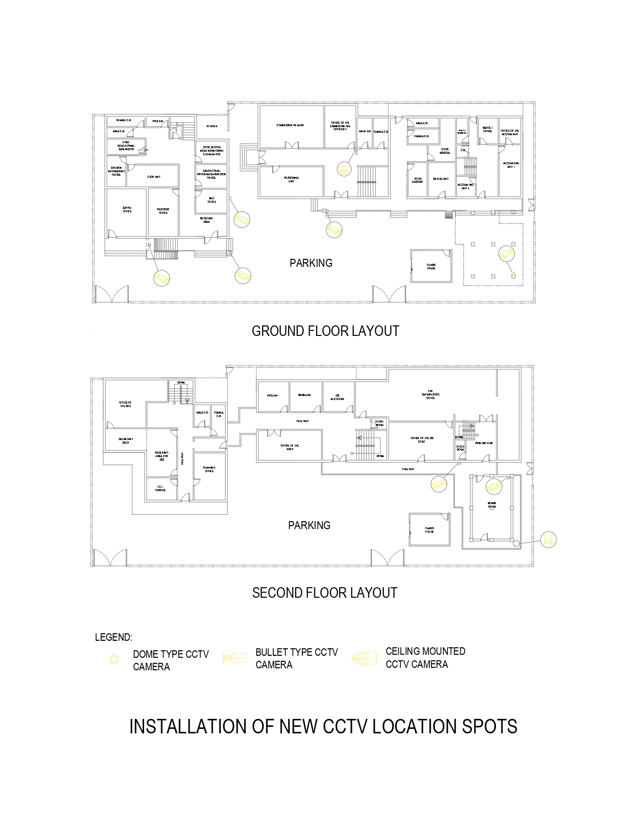
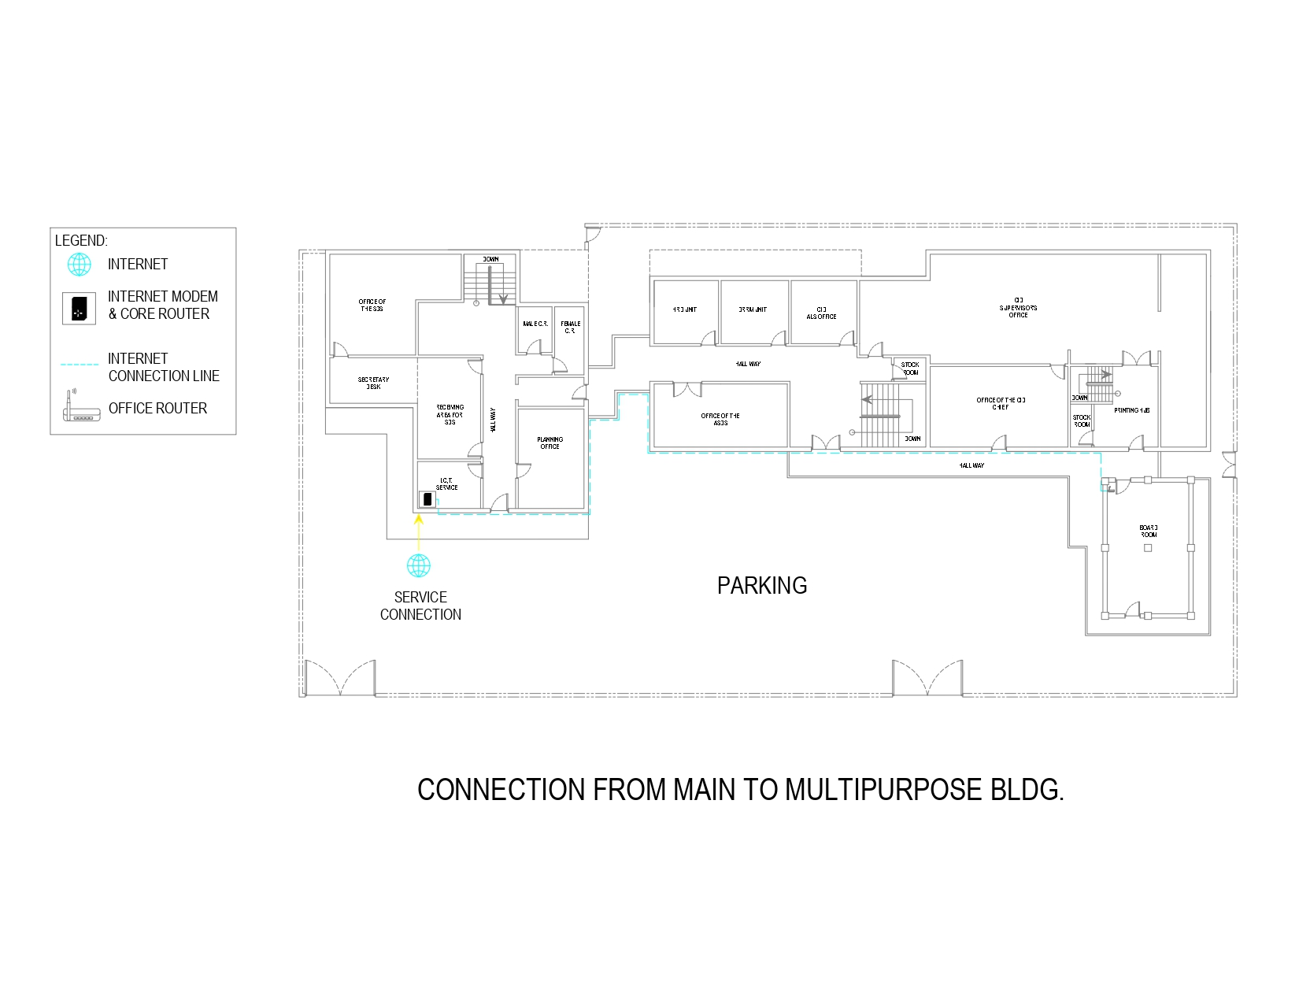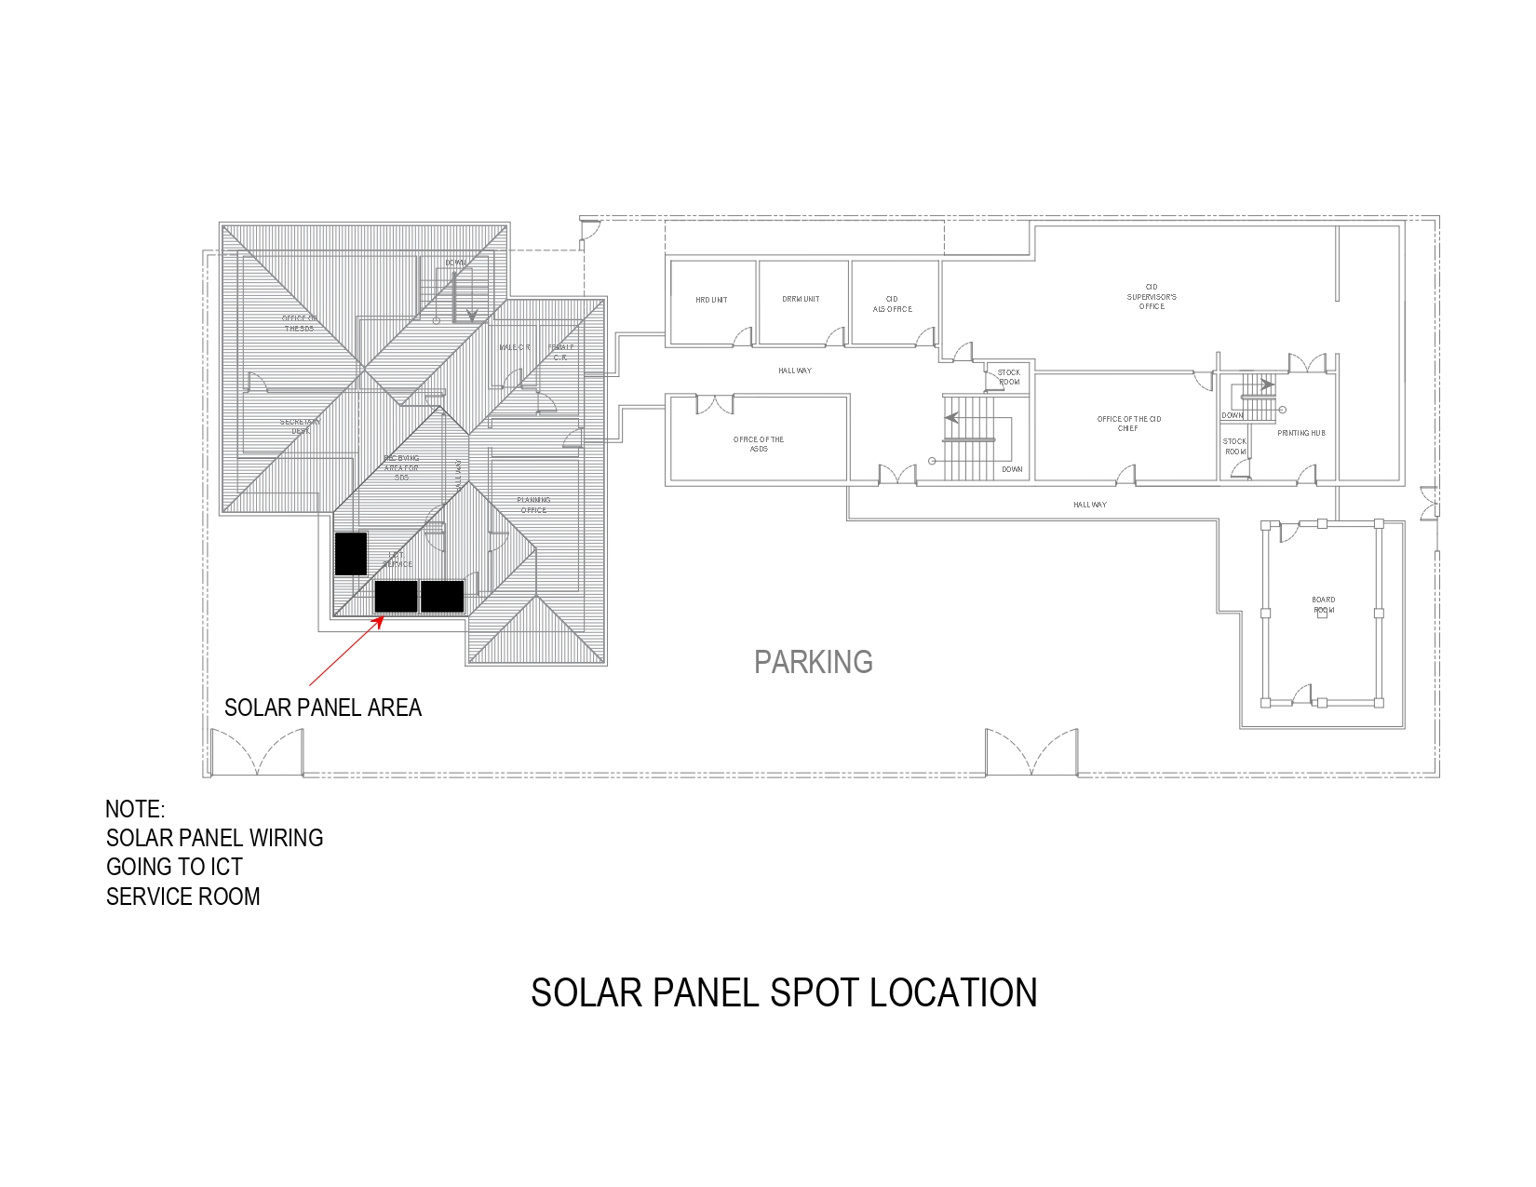

ORIGINAL/ COPY NO. _______________

BIDDER’S COMPANY NAME:
OFFICE ADDRESS:
PUBLIC BIDDING: (PROJECT TITLE)
BIDDING FOR (No.) : (Item Description) [If Applicable]

THE CHAIRPERSON
BIDS AND AWARDS COMMITTEE
DEPARTMENT OF EDUCATION
SCHOOLS DIVISION OFFICE OF ALAMINOS CITY
San Jose Drive, Poblacion, Alaminos City, Pangasinan

